**PRCS252 Cognitive Walkthrough Results and Analysis (Desktop):**

**Q1: How would you describe your experience with the app?**

* Easy
* Mild confusion
* High accessibility
* Titling of some tables is ambiguous

**Q2: On a scale of 1 – 5 (1 being most easy, and 5 being most difficult), how did you find completing the tasks set?**

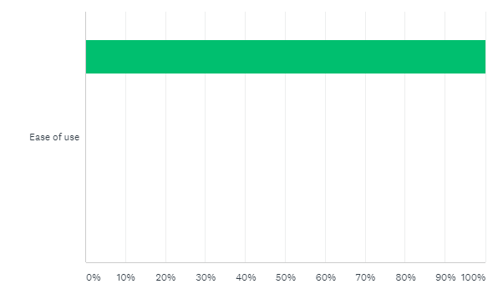

**Q3: On a scale of 1 – 5 (1 being mostly bad, 5 being mostly good), how would you rate your overall experience with the app?**

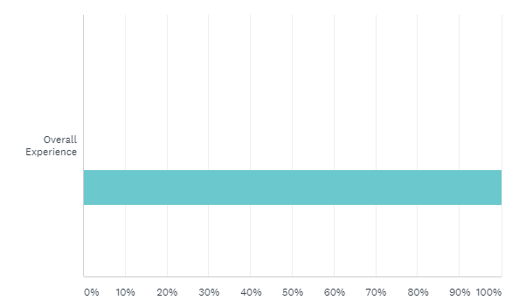**Q4: What features, if any, did you have difficulty using?**

* Viewing the routes.

**Q5: Is there anything you feel the app is missing usage-wise? (E.g. anything you feel would make it easier to use?)**

* Functionality for the other buttons

**Q6: What was, if any, your favourite feature of the app to use and why?**

* All of it was pretty much the same
* But all of it was good to use

**Q7: What was, if any, your least favourite feature of the app to use and why?**

* Viewing the shifts

**Q8: How did you feel when using the app’s navigation?**

